[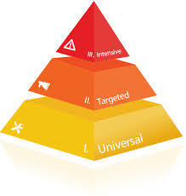](http://www.google.ca/imgres?imgurl=http://www.riosalado.edu/programs/education/rti/images/rti-pyramid-roman.png&imgrefurl=http://www.riosalado.edu/programs/education/rti/Pages/default.aspx&h=487&w=465&tbnid=byLoBL5OVHpsEM:&docid=Q5FK2vsVg8BwnM&ei=ZCrwVeqlKcmtyASv16X4Ag&tbm=isch&ved=0CDsQMygVMBVqFQoTCOrn-pb-6ccCFckWkgodr2sJLw)